**ADMINISTRATOR**

1. **Login Admin**

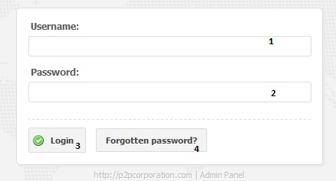

1. Enter the username
2. Enter the password
3. Click button “Login”. Check the username and password exists or not. If username and password are correct, it will display message “login successful” and go to the admin page:

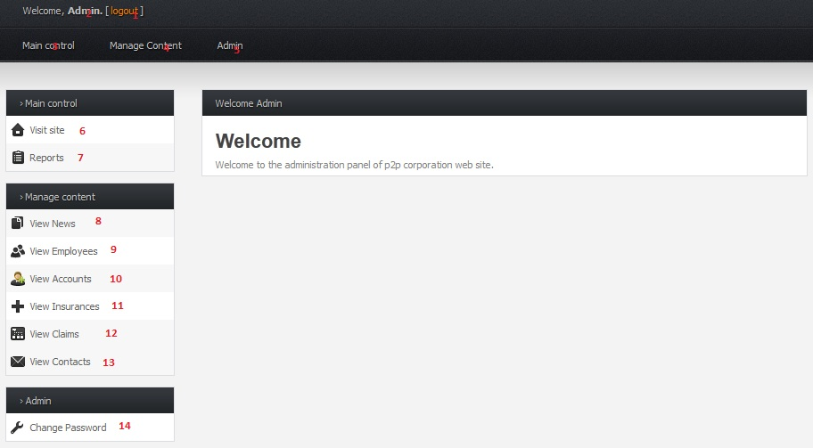

If username and password don’t exist, it will display message “Login failed” and return back to “Login” page

1. **Logout Admin**



1. Clicking “Logout” button will return login form for admin
2. **Change Password**

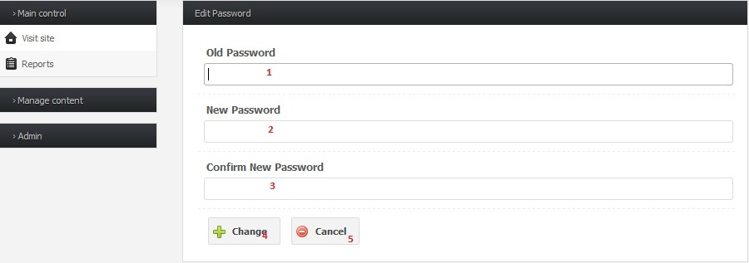

1. Enter old password
2. Enter new password
3. Enter again new password for confirmation
4. Click button “Change” to change password
   1. If any of fields is blank, it will pop-up a message to enter again
   2. An error message is also displayed if old password is the same as new password, or new password is different from new password confirmation
   3. If password is changed successfully, it redirects to Admin home page



1. **Manage Employee**

Admin clicks on “Manage Content” then chooses “Manage Employee” to go to “View Employee” page as figure below:

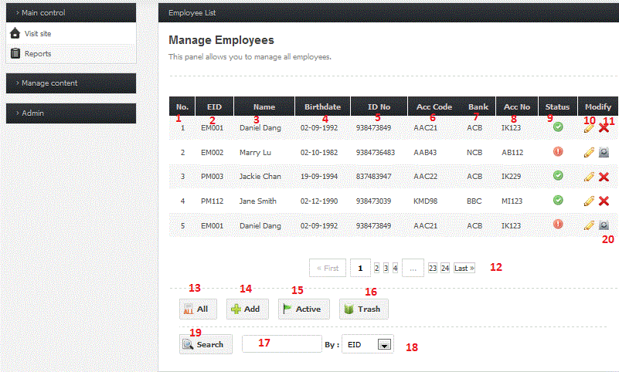

1. Click button “All” go to view all employees
2. Click button “Add” go to “add new employee” page

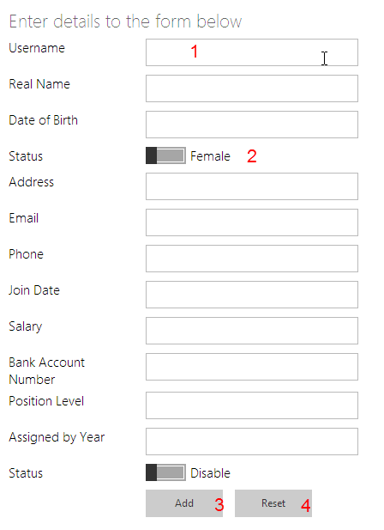

1. Enter username of employee
2. Switch Female and male of employee.
3. Click on button Add an employee will create employee.
4. Click on button Reset it will reset all text fields and switch
5. Click button “Deactivate”, employee will be deactivated when selected
6. Click button “Activate”, employee will be activated when selected
7. Click button “Trash”, it will redirect to Trash page, where all the deactivated employees are located, and they can be restored to be active
8. Click button “Search” after filling in the employee id or name to look for employees
9. **Manage Claim**

Admin clicks on “Manage Content” then chooses “Manage Claim” to go to “View Claim” page as figure below:

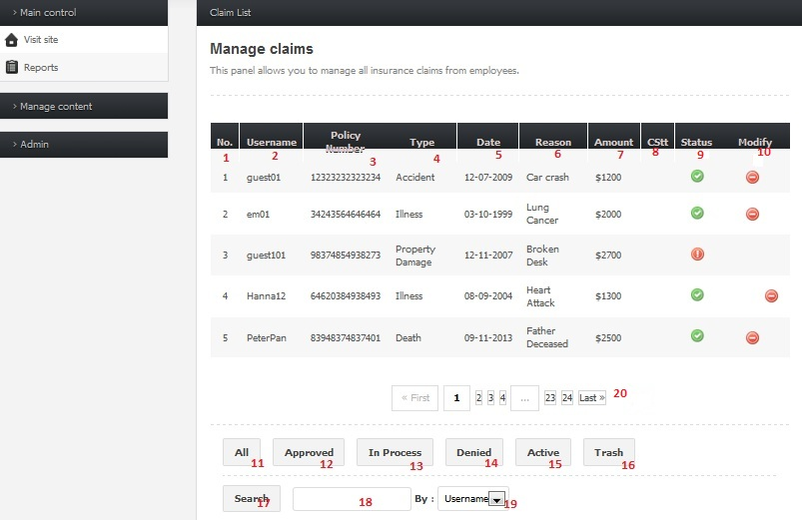

1. Click button “All” to view all the claims
2. Click button “Approved”, “In Process” or “Denied” to update the status of claims
3. Click button “Deactivate”, claim will be deactivated when selected
4. Click button “Activate”, claim will be activated when selected
5. Click button “Trash”, it will redirect to Trash page, where all the deactivated claims are located, and they can be restored to be active
6. Click button “Search” after filling in the username to look for claims
7. **Manage Account**

Admin clicks on “Manage Content” then chooses “Manage Account” to go to “View Account” page as figure below:

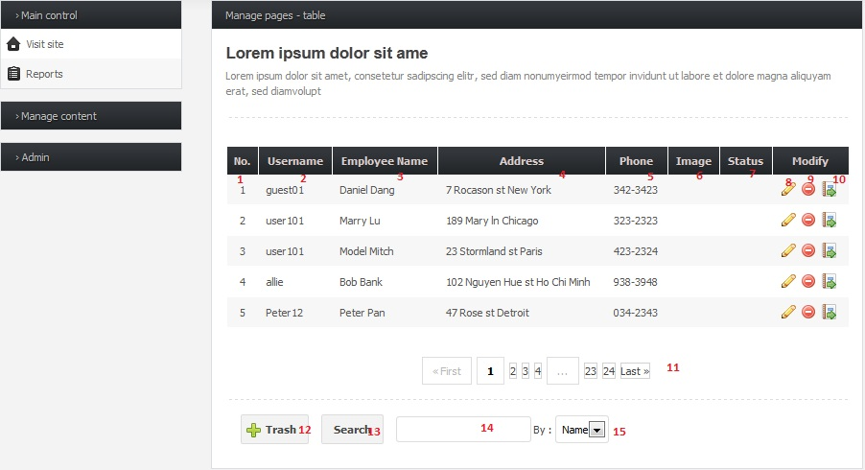

1. Click button “Add” to add new account
2. Click button “Edit” or “Delete” to update or deactivate the account

Click button “Activate”, account will be activated when selected

1. Click button “Trash”, it will redirect to Trash page, where all the deactivated accounts are located, and they can be restored to be active
2. Click button “Search” after filling in the username to look for accounts
3. **Manage FAQ**

Admin clicks on “Manage Content” then chooses “Manage FAQ” to go to “View FAQ” page as figure below:

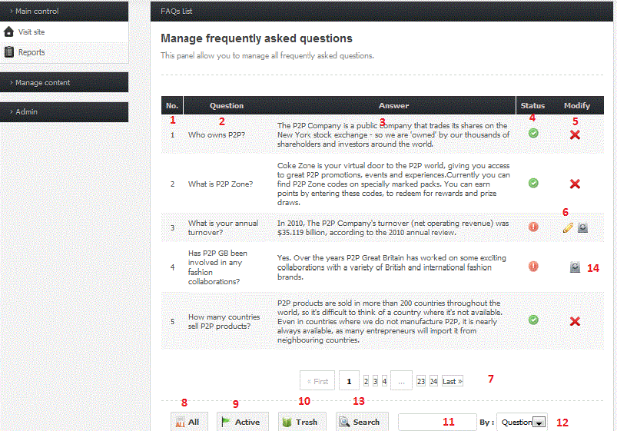

1. Click button “All” to view all the FAQs
2. Click button “Deactivate”, FAQ will be deactivated when selected
3. Click button “Activate”, FAQ will be activated when selected
4. Click button “Trash”, it will redirect to Trash page, where all the deactivated FAQs are located, and they can be restored to be active
5. Click button “Search” after filling any key word in question to look for FAQ
6. **Manage News**

Admin clicks on “Manage Content” then chooses “Manage news” to go to “View news” page as figure below:

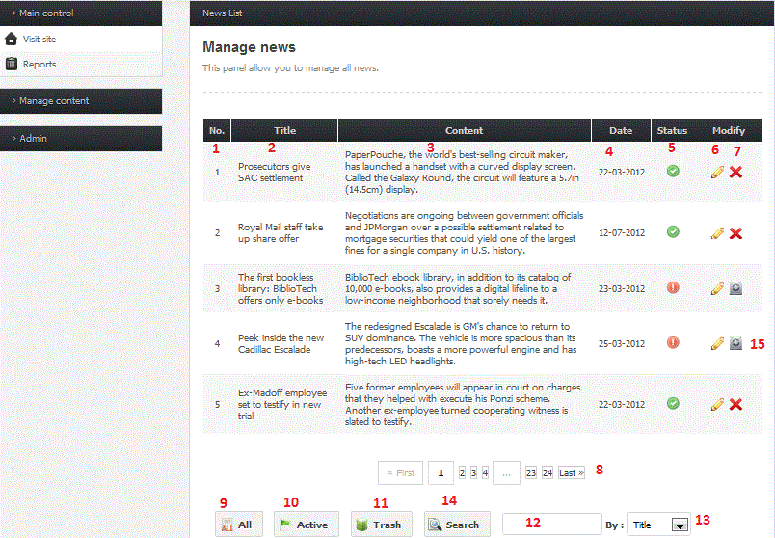

1. Click button “All” to view all the news
2. Click button “Deactivate”, news will be deactivated when selected
3. Click button “Activate”, news will be activated when selected
4. Click button “Trash”, it will redirect to Trash page, where all the deactivated news is located, and they can be restored to be active
5. Click button “Search” after filling the title to look for news
6. **Manage Insurance Type**

Admin clicks on “Manage Content” then chooses “Manage InsuranceType” to go to “View InsuranceType” page as figure below:

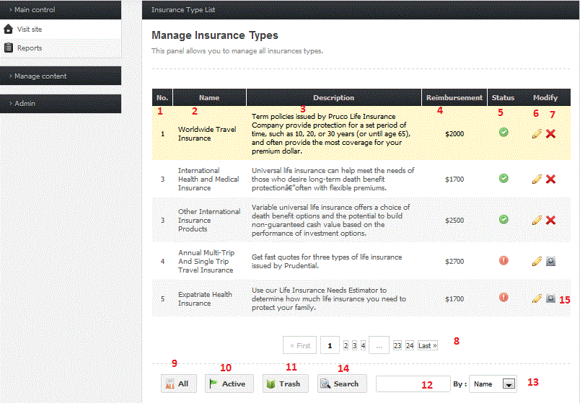

1. Click button “All” to view all the insurance types
2. Click button “Deactivate”, insurance type will be deactivated when selected
3. Click button “Activate”, insurance type will be activated when selected
4. Click button “Trash”, it will redirect to Trash page, where all the deactivated insurance types are located, and they can be restored to be active
5. Click button “Search” after filling the name to look for insurance types
6. **Manage Contact**

Admin clicks on “Manage Content” then chooses “Manage contact” to go to “View contact” page as figure below:

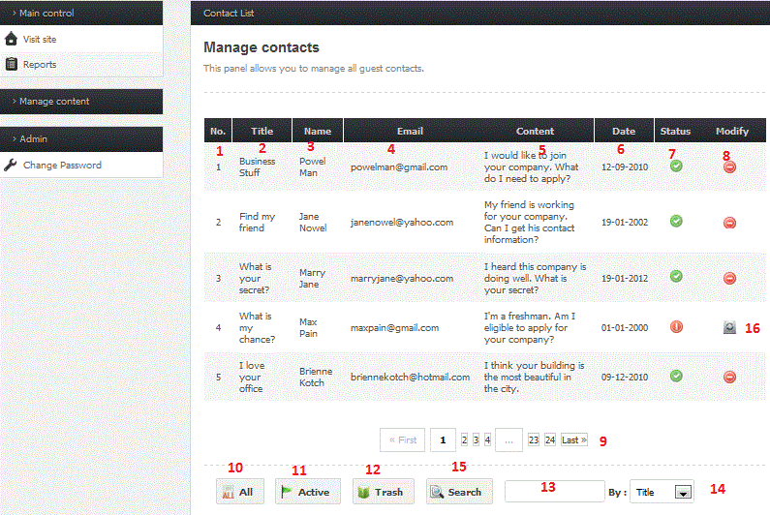

1. Click button “All” to view all the contacts
2. Click button “Deactivate”, contact will be deactivated when selected
3. Click button “Activate”, contact will be activated when selected
4. Click button “Trash”, it will redirect to Trash page, where all the deactivated contacts are located, and they can be restored to be active
5. Click button “Search” after filling the title to look for contacts

**GUEST**

As a guest, you can go to home page, view the news, our insurance products and contact us as below:



Home page



About us

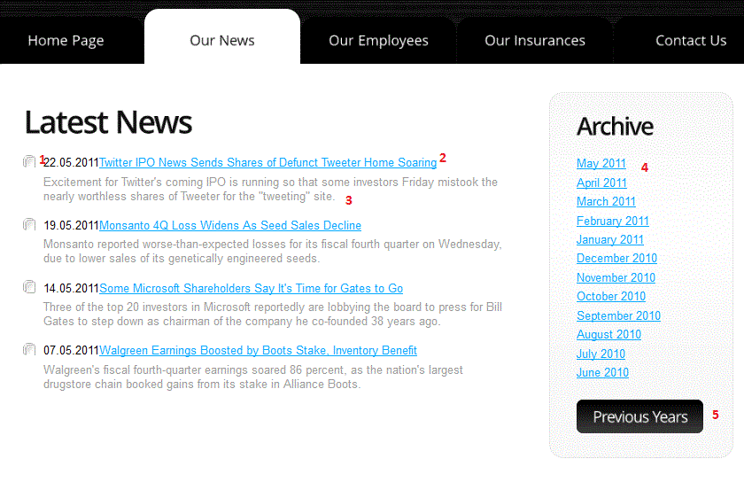

News

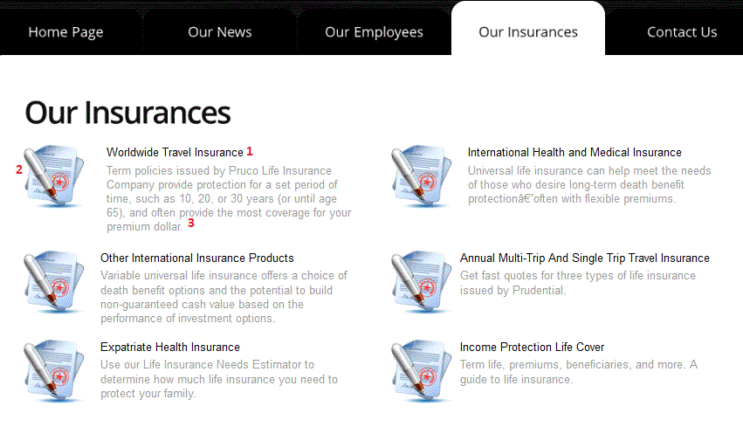

Our insurance products

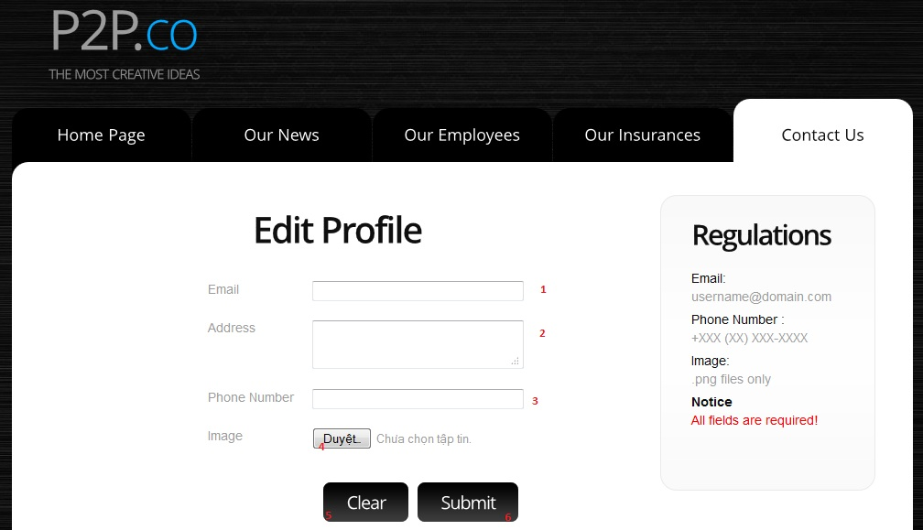

Contact us

**EMPLOYEE**

1. **Register**

Employee can go to “Our Employees” tab, then clicks register:

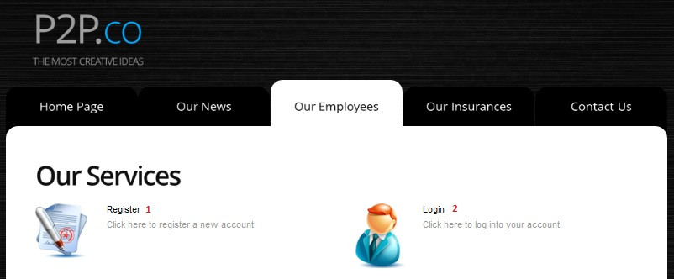

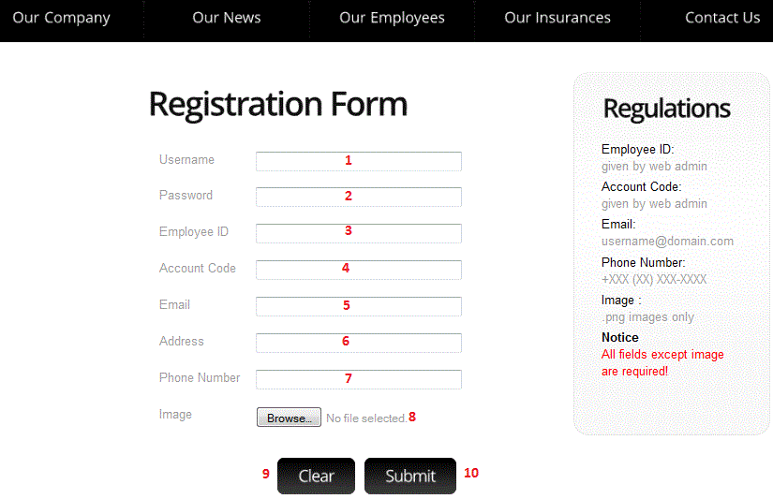

1. Enter the username and password
2. Enter the employeeID and Account Code given by administrator
3. Enter other information: email, address, phone number and image
4. Click on button “Submit”. It checks if the username and password exist, then checks if the employeeID and Account Code are correct. If yes, then the message box appears with successful registration notice.
5. **Login Employee**



1. Enter the username
2. Enter the password
3. Click button “Login”. Check the username and password exists or not. If username and password are correct, it will display message “login successful” and go to the employee page:

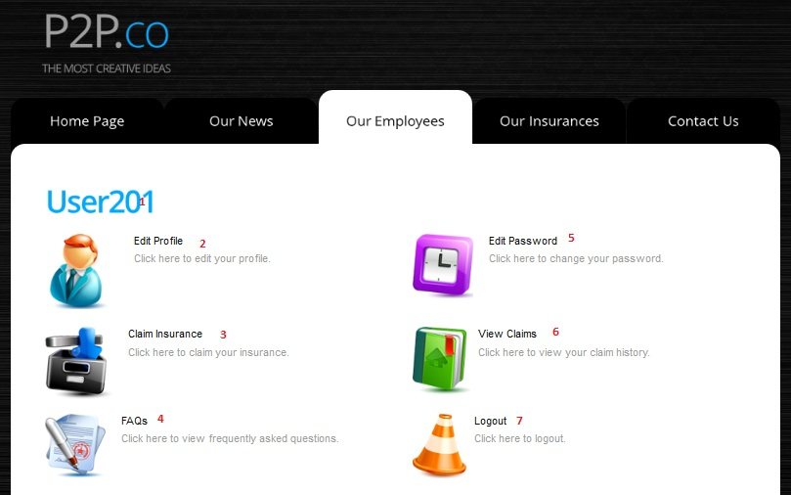

If username and password don’t exist, it will display message “Login failed” and return back to “Login” page

1. **Logout Employee**



1. Clicking “Logout” button will return login form for employee
2. **Change Password**

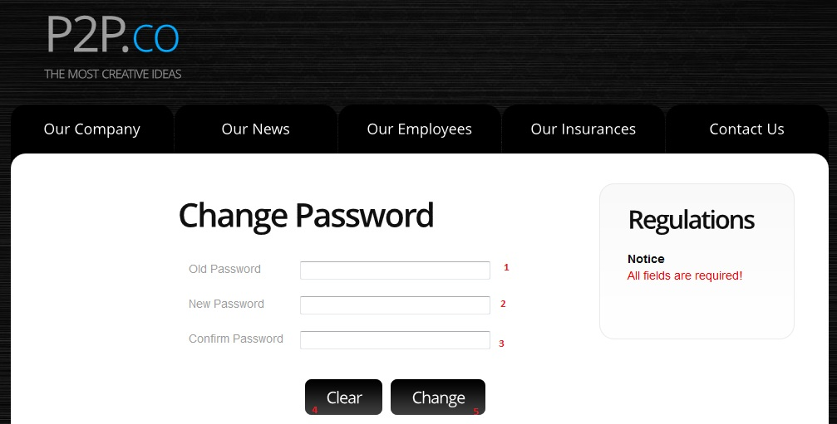

1. Enter old password
2. Enter new password
3. Enter again new password for confirmation
4. Click button “Change” to change password
   1. If any of fields is blank, it will pop-up a message to enter again
   2. An error message is also displayed if old password is the same as new password, or new password is different from new password confirmation
   3. If password is changed successfully, it redirects to Admin home page



1. **Edit profile**

After logon, employees can edit their profiles by clicking “Edit profile” in employee page



1. Enter email, address
2. Enter phone number and choose the image
3. Click button “Submit” to update the change. If any of fields is blank, it will pop-up a message to enter again
4. **Create and view claim**

After logon, employees can create new claim by clicking “claim insurance” in employee page

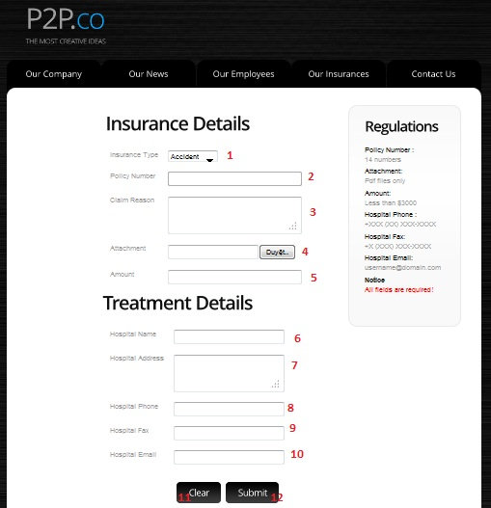

1. Enter all the insurance details: insurance type, policy number, claim reason, attachment,…
2. Enter treatment details: hospital name, address, email,…
3. Click button “Submit” to create new claim. If any of fields is blank, it will pop-up a message to enter again

Besides, employees can view all their previous claims by clicking “View claim”

